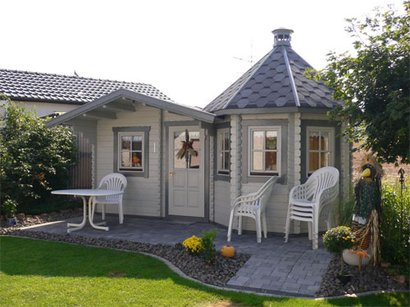

Nida-Tower Log Cabin
Roof projection: Front 1.10 m
Back 0.20 m
Side 0.30 m

Walls: Both Log Cabin and Pavilion are made from 45 mm double tongue and groove logs
Floor: 20 mm tongue and groove floor boards on the impregnated base frame
Roof: 20 mm tongue and groove roof boards
Door: 1 glued cartridge door 90/196 with seal
Windows: Log Cabin - double-glazed 80/94 tilt ‘n‘ turn unit
Pavilion - double-glazed 70/94 tilt ‘n‘ turn units

Log Cabin Size (m) |  | Tower Size (m) | Price (£)
B | T | Diameter | Price (£)
3.1 | 2.51 | 2.5 | 4690

Extras:

Roof Insulation Call for Price
Roof Tiles Call for Price
Tower in 60 mm with partition wall and Sauna Call for Price
Furniture £470
(7 benches, 1 table)

